**Experiment-3**

**Aim:** To implement a view level design using CREATE VIEW,ALTER VIEW and DELETE VIEW ddl commands.

Creating a table:

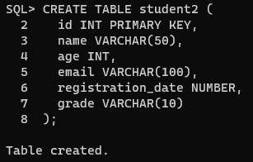

By using insert command we can insert values in a tables

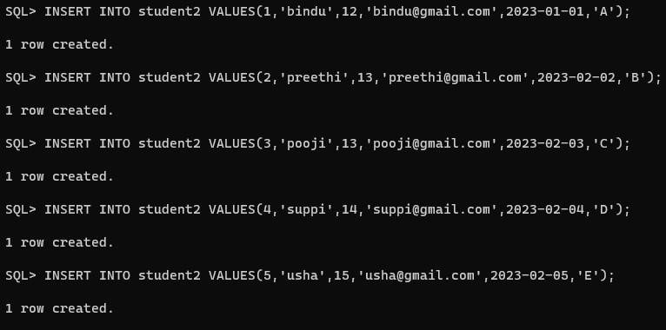

**Creating view councellor:**

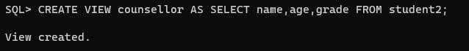

Inserting values into councellor:



Selecting specific row :

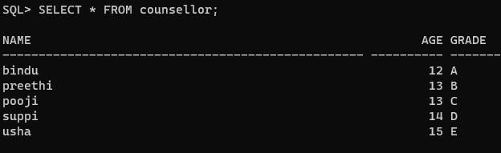

**Update :**

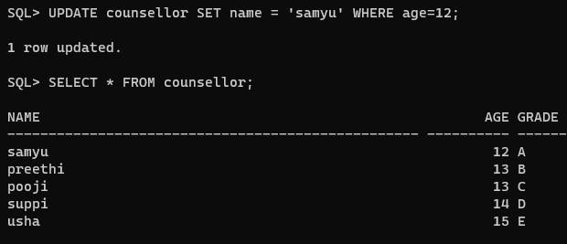

**truncate or drop view:**

